Portsmouth Guildhall Access Guide
- Introduction

Our vision is to inspire, entertain and transform lives through music, arts and heritage and we are committed to providing the best possible experience to all, ensuring that your visit is welcoming and accessible.

- Contact Details
To speak to someone about access provision at the venue, please get in touch with our Box Office team:
Email: Access@portsmouthguildhall.org.uk
Phone: 02393 870 200 (open Monday-Friday 9am-5pm, and on the evening on an event)
Postal: FAO Access, Portsmouth Guildhall Box Office, Portsmouth Guildhall, Portsmouth, PO1 2AB
We aim to respond to your access enquiry within 5 working days

- Venue Description
There is gentle ramp access from outside, into our main foyer for wheelchair users and those with limited mobility. From here the stalls of the Auditorium, the Guildhall Studio space, the Square Kitchen Café are all accessible.
Our toilets, including the Accessible Toilets, are on the basement level which can be accessed by lifts on both sides of the foyer. Please see below for the lift dimensions. All other areas of the Guildhall can also be accessed by these lifts.
LIFT DIMENSIONS

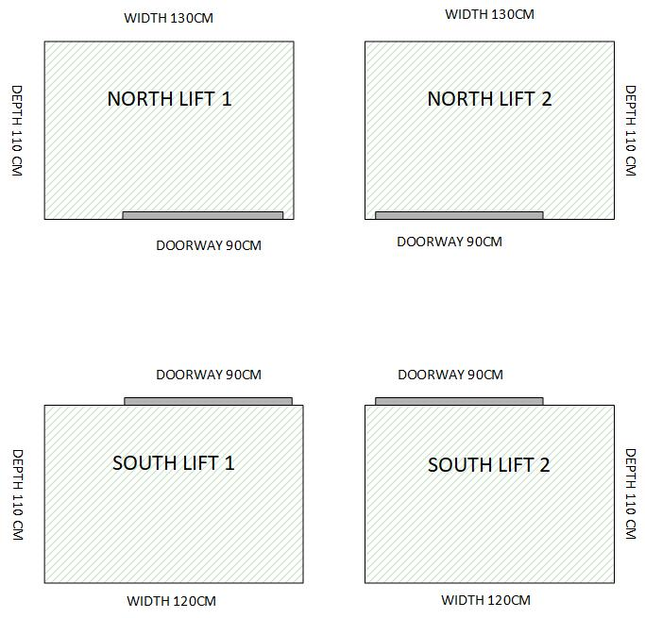

SEAT DIMENSIONS
The legroom in the Main Auditorium varies between the Stalls, Upper Stalls and Circle. Below is a guide to seat widths and legroom. Please note that all seats have fixed arm rests, and legroom is measured from the front edge of your seat to the back of the seat in front. All measurements are in millimetres.
Stalls:
Seat width: 420mm
Leg room: 300mm
Upper Stalls:
Seat width: 420mm
Leg room: 240mm
Circle:
Seat width: 420mm
Leg room: 200mm
Seats in The Lens Studio are freestanding with no arm rests and have a width of 470mm.

Our Box Office and Auditorium have hearing induction loop systems in place, please see 11.1 Facilities for Deaf and Hard of Hearing Patrons for more information.
If you require any assistance whilst in our building, please ask a member of staff and we will be happy to help and can advise on best routes and access points.

- Access Facilities
We’re happy to offer complimentary tickets for companions. As standard, our wheelchair positions and other ‘Accessible Seats’ come with one free ticket.
Our Main Auditorium has a wheelchair platform located at the back of the Upper Stalls Area. This is accessed via a wheelchair lift in the corridor, capacity of which is:
Maximum Load is 250kg / 550lb
Operational length of wheelchair with person 100cm / 3 Feet 3 inches
Operational width of wheelchair with person 70cm / 2 feet 3.5 inches

Free standing seats are positioned next to wheelchair spaces for companions.
For ambulant disabled/ non-wheelchair users and their companions, you can choose to sit in any area of the auditorium. Our Box Office team are happy to support you in making a decision as to where best to sit.
The closest accessible toilets to the wheelchair platform are located in the Basement area of the building. There is lift access to the toilets. Please see above for lift dimensions.

- How to book accessible tickets
Wheelchair accessible tickets and companion tickets are available online for any show, these can be booked directly through our website on the event booking page.
If you require an ambulant disable and companion ticket, please contact our box office, via the contact details above.
Accessible tickets are available for all presales and early bird offers, along with general sales.

5.1 Proof of eligibility
We ask you to provide us with one of the following documents, so that we can issue a complimentary companion ticket:
- Front page of DLA/PIP (no specific rate required)
- Front page of Attendance Allowance Letter (no specific rate required)
- Evidence that registered severely sight impaired (blind)
- Recognised Assistance Dog ID card
- Blue Badge
We recognise that the evidence above might not include everyone that has an access requirement. If you do not have any of the above evidence but wish to apply for a companion ticket, please complete the Access Requirement Form stating why you require one. You are welcome to post or email copies of any additional evidence that supports your application if you have any or contact us to discuss your application.

- Getting to Portsmouth Guildhall
There is no accessible parking available directly at the Guildhall.
Please see the following page for general information about travel and parking, including accessible parking: How to Get to Us

Blue Badge holders are exempt from pay and display charges in Portsmouth City Council owned car parks – just display your badge. This is not the case with NCP owned car parks or the Isambard Brunel Multi Storey car park.
Customers can be dropped off outside the building, along King Henry 1st Street.

6.1 Parking
Isambard Brunel Multi Storey Car Park has 460 spaces and is 200m from Portsmouth Guildhall.
When attending a show with us you can purchase an ‘exit ticket’ for this car park, either at the point of booking or on the day of the show.
Your pre-paid QR code/confirmation is NOT your exit ticket. Please collect this from the box office in exchange for your entry ticket. Upon entry at the Isambard Brunel Multi-Storey car park in Alec Rose Lane, Portsmouth, PO1 2BX the driver must take the entry ticket at the barrier. Upon exit, the driver must insert the ‘Exit’ ticket (collected from the box office in exchange for entry ticket) in place of the ticket taken at the barrier. The ticket costs £4.50 and is valid for 6 hours from 6pm seven days a week. This ticket may be purchased in advance or on when visiting a show having already parked in the car park.

There are a very limited number of on street parking spaces outside the venue.
There is a drop curb outside the venue for drop off.
For more information on car parking in Portsmouth please see Portsmouth City Council website.

6.2 By Taxi
There is a taxi rank for metered taxis on Guildhall Walk outside the venue.
There is a drop curb outside the venue for taxi drop off.
Our featured Taxi partner, Aquacars, is the 3rd largest taxi provider in the UK and taxis can be ordered on 023 9265 4321 or via their app.

6.3 By Train
Portsmouth Guildhall is just across the square from Portsmouth & Southsea Train Station with frequent services operating to London Waterloo, Southampton and Brighton.

6.4 By Bus
Local and regional bus services stop at Commercial Road City Centre which is a 5 minute walk from Portsmouth Guildhall. National coach services will stop at The Hard Interchange, a 15 minute walk or short taxi ride away.
www.firstgroup.com/ukbus/hampshire

6.5 By Water
Services to Isle of Wight are operated by:
Hovertravel
Wightlink Ferries

Frequent 4-minute crossings to Gosport are operated by:
Gosport Ferry

Please use our Visual Story to help you plan your visit.

- Arrival Guide
The Box Office is open: 9am-5pm, Monday- Friday, and at least half an hour before a show.
When you arrive, there might be a queue down the road of people waiting to get in. There will be security stewards directing this queue. If you require early access, make yourself known to one of these stewards who will be able to contact the box office manager, duty manager or assistant manager on your behalf. They will in turn be able to direct you of the best course of action. Alternatively, come straight to the box office from where we will also be able to help you.
To pick up your tickets, you will need a form of identification – a payment card will be fine unless the performance information specifically states that you’ll need to produce photographic ID. You will also be asked to verify your postcode too. We only ask this to ensure we’re giving the tickets to the right people. You will not be asked for any ‘proof of disability’ to pick up your access tickets, though you or others in your party may be asked to provide proof of age to pick up any concessionary rate tickets or if there is an age restriction on the event.
Once you’re inside, there will be a number of security staff as well as front of house staff. If you need any assistance or you have any concerns or questions, please don’t hesitate to ask any of them for assistance.

- Toilets
Accessible toilets are available in the Basement and 1st floor areas and can be accessed by a lift.
All fittings comply with Part M of the Building Regulations.
We do not currently offer a Changing Places toilet facility, but we will be including these in the toilet renovations.

- Customers with Medical Requirements
We welcome audience members who need to bring medicines, medical equipment, food or drink to manage a medical condition. If you have any concerns about being allowed entry with any items you require, please don’t hesitate to get in touch. For performances and large events, we have trained medics on site and all of our duty and management staff are First Aid trained.

- Access to the Performance

10.1 Facilities for Deaf and Hard of Hearing Patrons:
Our Box Office and auditorium have hearing loop systems in place.
If you would like to use these, you will need to switch to the t-system on a hearing aid.
Please note- it is recommended that, if you require use of the hearing loop system, that tickets are purchased in the Stalls or Upper Stalls area of the auditorium.
Details of signed performances will be listed on individual production pages. Alternatively, you can search for British Sign Language in our search function on the website. If a performance doesn’t have any dates listed and you would be interested in using this service, please get in touch with us via access@portsmouthguildhall.org.uk and we may be able to arrange this.

10.2 Venue Accessibility for Wheelchair Users:
We have lowered counter positions at our Box Office.
Although our bars do not have dropped counters for service to wheelchair users, our bar staff are briefed to come out from the bar to take your order.
Accessible toilet facilities can be found on the Basement level and 1st Floor.
We have a number of wheelchair and companion spaces on our wheelchair platform in the Main Auditorium. Please see the Venue Accessibility and How to book accessible tickets of this guide.
In our Studio, we have a number of wheelchair spaces that are reserved until the performance sells out, at which point they will be put on general sale. It is possible to put a chair back in to the space if you decide you would like to transfer from your wheelchair into a seat, just let the Duty Manager know.

- Assistance Dogs
Guide dogs and assistance dogs are all welcome in our building. If you would like your dog to be looked after whilst you are watching an event, this can be pre-arranged by getting in touch in advance. We will arrange for someone to meet you at Box Office, guide you to your seat and stay with your dog throughout the event.

- Strobe Lighting
Occasionally, performances will use Strobe Lighting. We will update the relevant Performance Information page on our website if we find out it is being used, as we understand this could impact people attending. If you have any concerns, please get in touch, and we will contact the relevant external company to enquire. If strobe lighting is being used as part of a performance that you have purchased tickets to, we will of course offer a refund or exchange.
We will put a notice up if strobe lighting is being used for a performance.

With any performance, please feel free to get in touch with us if you need any information on an event to help you decide if it’s going to be right for you.

