Portsmouth Guildhall Access Guide
- Introduction
Our vision is to inspire, entertain and transform lives through music, arts and heritage and we are committed to providing the best possible experience to all, ensuring that your visit is welcoming and accessible.

- Contact Details
To speak to someone about access provision at the venue, please get in touch with our Box Office team:
Email: Access@portsmouthguildhall.org.uk
Phone: 02393 870 200 (open Monday-Friday 9am-5pm, and on the evening on an event)
Postal: FAO Access, Portsmouth Guildhall Box Office, Portsmouth Guildhall, Portsmouth, PO1 2AB
We aim to respond to your access enquiry within 5 working days

- Venue Description
There is gentle ramp access from outside into our main foyers for wheelchair users and those with limited mobility. From here the Stalls (main auditorium), the Lens Studio and the Square Kitchen Café all have step-free access.
Our toilets, including Accessible Toilets with left and right transfers as well as changing facilities, are on the basement level which can be accessed by lifts on both sides of the ground floor (please see point 8. for information regarding our Accessible Toilet facilities and specific locations). Please see below for the lift dimensions. All other areas of the Guildhall can also be accessed by these lifts.

Lift Dimensions

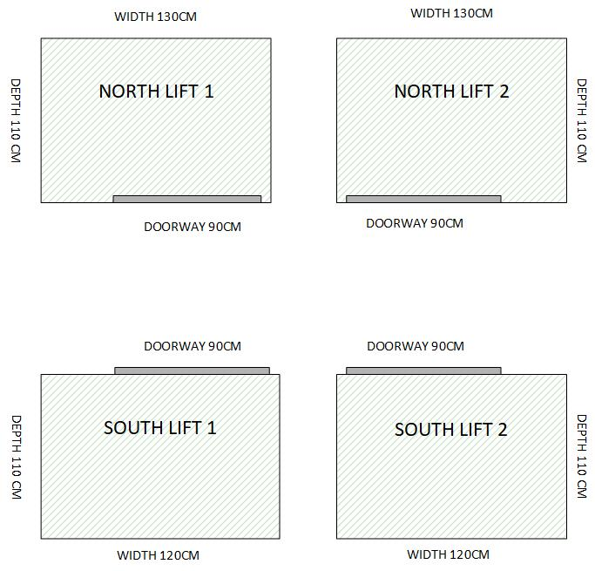

Seat Dimensions
The legroom in the Main Auditorium varies between the Stalls, Upper Stalls and Circle. Below is a guide to seat widths and legroom. Please note that all seats have fixed arm rests, and legroom is measured from the front edge of your seat to the back of the seat in front. All measurements are in millimetres.
Stalls:
Seat width: 420mm
Leg room: 300mm
Upper Stalls:
Seat width: 420mm
Leg room: 240mm
Circle:
Seat width: 420mm
Leg room: 200mm
Seats in The Lens Studio are freestanding with no arm rests and have a width of 470mm.
Our Box Office and Auditorium have hearing induction loop systems in place, please see 11.1 Facilities for Deaf and Hard of Hearing Patrons for more information.
If you require any assistance whilst in our building, please ask a member of staff and we will be happy to help and can advise on best routes and access points.

- Access Facilities
Complimentary companion tickets are offered alongside a Wheelchair space or Ambulant ticket. 1 free ticket is offered alongside 1 ticket purchased at full price.
Our Main Auditorium has a wheelchair platform located at the back of the Upper Stalls Area. This is accessed via a wheelchair lift in the corridor, capacity of which is:
Maximum Load is 250kg / 550lb
Operational length of wheelchair with person 100cm / 3 Feet 3 inches
Operational width of wheelchair with person 70cm / 2 feet 3.5 inches
Free standing seats are positioned behind wheelchair spaces for companions.
For ambulant disabled/non-wheelchair users and their companions, you can choose to sit in any area of the auditorium. Our Box Office team are happy to support you in planning where best to sit.
The closest accessible toilets to the wheelchair platform are located in the Basement area of the building. These accessible toilets include both left and right transfer including an adult changing bed with hoist (please see point 8. for information regarding our Accessible Toilet Facilities). There is lift access to the toilets. Please see above for lift dimensions.
We have lowered counter position at our Box Office. We have a lowered bar counter available in our Stalls Bar.

- How to book accessible tickets
Accessible tickets including complimentary companion's tickets for Ambulant & Wheelchair Accessible Customers can be purchased by:
- Creating an account via our website - Login - Online shop or informing our Access Team of an existing account.
- Sending our Access Team proof of one of the pieces of evidence included in 5.1.
3) We will then register your account to receive a complimentary carers ticket
4) Once registered you can book accessible tickets via our website using your account login
5) To book tickets you will need to add either the Wheelchair User Ticket or Ambulant ticket to your basket and will be able to add the free carers ticket alongside.
If you have any problems accessing complimentary carers tickets via our website, please contact our Access Team so we can resolve this.
Accessible tickets are available for all presales and early bird offers, along with general sales via our website.
Due to demand for certain shows, we suggest registering for an accessible account before the general on-sale period and making sure you can access and add complimentary carers tickets for other events.

5.1 Proof of eligibility
We ask you to provide us with one of the following documents, so that we can issue a complimentary companion ticket:
- Front page of DLA/PIP (no specific rate required)
- Front page of Attendance Allowance Letter (no specific rate required)
- Evidence that registers as severely sight impaired (blind)
- Recognised Assistance Dog ID card
- Access Cards

We recognise that the evidence above might not include everyone that has an access requirement. If you do not have any of the above evidence but wish to apply for a companion ticket, please complete the Access Requirement Form, found on the Access section of our website: Access | Portsmouth Guildhall, stating why you require one. You are welcome to post or email copies of any additional evidence that supports your application if you have any or contact us to discuss your application.

- Getting to Portsmouth Guildhall
There is no accessible parking available directly at the Guildhall.
Please see the following page for general information about travel and parking, including accessible parking: How to Get to Us

Blue Badge holders are exempt from pay and display charges in Portsmouth City Council owned car parks – just display your badge. This is not the case with NCP owned car parks or the Isambard Brunel Multi Storey car park.
Customers can be dropped off outside the building; the road is King Henry 1st Street.

6.1 Parking
There are a very limited number of on street parking spaces outside the venue on King Henry 1st Street.
There is also a drop curb outside the venue for drop off on King Henry 1st Street.
For more information on car parking in Portsmouth please see Portsmouth City Council website: Car parks - Portsmouth City Council
Blue Badge holders can park in Isambard Brunel Pay and Display car park (not multi storey).
The Isambard Brunel Multi Storey Car Park has 460 spaces and is 200m from Portsmouth Guildhall.
When attending a show with us you can purchase an ‘exit ticket’ for this car park and the venue.

6.2 By Taxi
There is a taxi rank for metered taxis on Guildhall Walk outside the venue.
There is a drop curb outside the venue for taxi drop off.
Our featured Taxi partner, Aquacars, is the 3rd largest taxi provider in the UK and taxis can be ordered on 023 9265 4321 or via their app (Veezu).

6.3 By Train
Portsmouth Guildhall is just across the square from Portsmouth & Southsea Train Station with frequent services operating to London Waterloo, Southampton and Brighton.

6.4 By Bus
Local and regional bus services stop at Commercial Road City Centre which is a 5-minute walk from Portsmouth Guildhall. National coach services will stop at The Hard Interchange, a 15-minute walk or short taxi ride away.

6.5 By Water
Services to Isle of Wight are operated by:
Hovertravel
Wightlink Ferries

Frequent 4-minute crossings to Gosport are operated by:
Gosport Ferry

- Arrival Guide
The Box Office is open: 9am-5pm, Monday- Friday, and at least an hour before a show.
When you arrive, there might be a queue of people waiting to enter the venue through the main entrance. There will be security stewards directing this queue.
If you have access needs, the security stewards will direct you to the accessible entrance when you arrive. If further assistance is required, please go to the Box Office who will be happy to help.
All our tickets are now sent as E-Tickets, which can be printed for entry, or you can show the QR code attached to your order confirmation for entry. However, if you have requested to pick up your tickets, you will need a form of identification – a payment card or photographic ID is fine. You will also be asked to verify your postcode too. We only ask this to ensure we’re giving the tickets to the right people.
You will not be asked to show your accessible proof again, though you or others in your party may be asked to provide proof of age to pick up any concessionary rate tickets or if there is an age restriction on the event.
Once you’re inside, there will be a team of front of house staff and security should you require any further assistance.

- Toilets
Accessible toilets are available in the Basement and 1st floor areas and can be accessed by a lift.
All fittings comply with Part M of the Building Regulations.
Our new accessible toilet facilities including left and right transfers as well as an adult changing bed with hoist can be found in our basement area.
The closest toilets to the wheelchair accessible platform are in the north side of the venue, which contains two small accessible toilets with a right transfer.
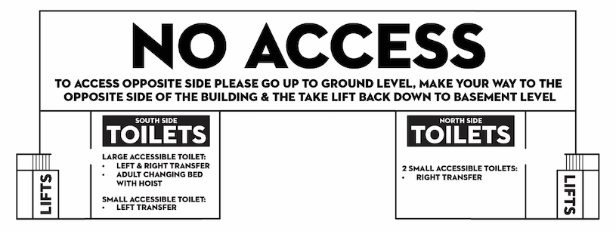
The image below acts as a basic guide and our front of house team would be happy to guide you to the required accessible toilet.

- Customers with Medical Requirements
We welcome audience members who need to bring medicines, medical equipment, food or drink (sealed) to manage a medical condition. If you have any concerns about being allowed entry with any items you require, please don’t hesitate to get in touch. For performances and large events, we have trained medics on site and members of our management staff are First Aid trained.

- Access to the Performance

10.1 Facilities for Deaf and Hard of Hearing Patrons:
Our Box Office and auditorium have hearing loop systems in place.
If you would like to use these, you will need to switch to the t-system on a hearing aid.
Please note- it is recommended that, if you require use of the hearing loop system, that tickets are purchased in the Stalls or Upper Stalls area of the auditorium.
Details of signed performances will be listed on individual production pages. Alternatively, you can search for British Sign Language in our search function on the website. If a performance doesn’t have any dates listed and you would be interested in using this service, please get in touch with us via access@portsmouthguildhall.org.uk and we may be able to arrange this.

10.2 Venue Accessibility for Wheelchair Users:
We have a lowered counter position at our Box Office.
The Stalls Bar has a dropped counter for service to wheelchair users, however all staff in other bars throughout the venue will be happy to assist wheelchair users with their orders.
Accessible toilet facilities can be found on the Basement level and 1st Floor. (Please see point 8. for information regarding our Accessible Toilet Facilities).
We have 5 wheelchair and companion spaces on our wheelchair platform in the Main Auditorium. Please see 4. and 5. for more information.
The Lens Studio is always sold as general admission and there is no separate accessible area due to the size of the room. There is not a raised viewing platform for Wheelchair users, all patrons will be in the same area on the flat floor. Ambulant and Wheelchair bookings are still accommodated with an essential companion ticket.
- Assistance Animals
Guide dogs and assistance animals are all welcome in our building. If you require an assistance dog whilst attending a show, please make us aware and ensure suitable seating is booked with Box Office.

- Strobe Lighting
Occasionally, performances will use Strobe Lighting. We will update the relevant Performance Information page on our website if we find out it is being used, as we understand this could impact people attending. If you have any concerns, please get in touch, and we will contact the relevant external production company to enquire. If strobe lighting is being used as part of a performance that you have purchased tickets to, we will of course offer a refund or exchange your tickets.
We will also put a notice up if strobe lighting is being used for a performance in our front of house areas.
With any performance, please feel free to get in touch with us if you need any information on an event to help you decide if it’s going to be right for you.

