
TITLE: Junior Graphic Design Assistant
DEPARTMENT: Marketing
RESPONSIBLE TO: Senior Graphic Design & Marketing Officer
HOURS: 20 hours per week
CONTRACT: 6 Month Fixed Term Contract
PAY: National minimum wage for the age of employee.
(Per hour - £12.71 for workers aged 21+, £10.85 for workers aged 18-20, £8.00 for workers under 18)
Purpose of Role
This is an exciting entry level position to develop your creative design skills whilst working alongside our experienced marketing team on all aspects of Graphic Design. You will translate briefs into creative visual designs for print, web and social media, ensuring all assets align with established brand guidelines. You will create engaging content and materials for a range of audiences.
Organisation Chart
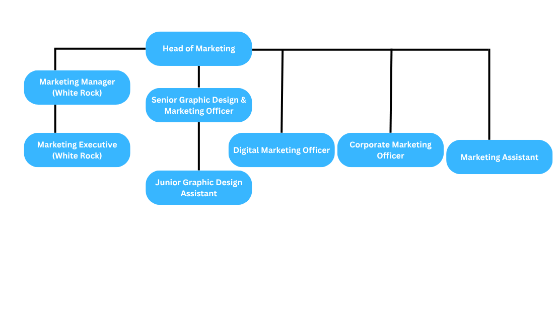
Principal Responsibilities

1. | Adapt existing designs and templates for a wide array of uses. | 40%
2. | Follow a design brief to create new designs for a wide range of uses and audiences. | 25%
3. | Understand audiences and how to adapt designs for the target market | 5%
4. | Create audio visual assets for social media and digital campaigns | 10%
5. | Understand the design to print process and prepare files for print. | 5%
6. | Understand and follow brand guidelines. | 5%
7. | Research competitors and current design trends and styles | 5%
8. | Write basic marketing copy | 5%

Other
The nature of the work undertaken by the post holder will be required to work flexibly to meet the needs of the department and the organisation. This may include working occasional evenings and weekends, for which time in lieu will be given.
Budget
The post holder will not manage budgets.
Physical
Occasional lifting.
Location
The post holder will be located at Portsmouth Guildhall. (PO1 2AB)
Context
The Guildhall Trust (GHT) has established an excellent reputation as one of the South of England’s leading cultural organisations through its flagship venue, Portsmouth Guildhall and its sister venue The White Rock Theatre, Hastings.
Portsmouth Guildhall is a Concert Hall and conferencing centre, which hosts a world class programme of music, comedy, dance, drama and family shows, conferences, meetings and events. The Trust has developed an extensive learning and participation programme and produces and promotes its own events, including Dance Live!, Portsmouth Comic Con and Summer Concerts in the Square.
The White Rock Theatre in Hastings is a large scale, 1055 seat venue, with a large 250 capacity studio. It provides a mixed programme of music, comedy, musicals, pantomime and entertainment. Like the Guildhall, it also has a strong conferencing and meetings offer as well as a successful programme of learning and participation.
You will create assets for both of these venues.

Person Specification
This acts as a selection criteria and gives an outline of the type of person the characteristic required to do the job.
Essential: - without which the candidate would be rejected
Desirable: - useful for choosing between two good candidates
Attribute | Essential | Desirable
Experience |  | Work in a professional environment
Skill/ Abilities | Previous design skills  Good verbal and written communication skills.  Good organisation and time management skills  Competent IT skills – including the use of Adobe Creative Cloud  Creative flair and an eye for detail.  Hands on approach and team player.
Education and training | A-Level, BTEC or Level 3 Diploma in Graphic Design or equivalent qualification.  GCSE English (Grade 4-9 / A*-C)  GCSE Maths (Grade 4-9 / A*-C)
Other | Willing to work occasional evenings and weekends

DIVERSITY COMMITMENT
The Guildhall Trust is committed to promoting equalities and celebrating diversity and we welcome applications from people from diverse and underrepresented backgrounds.
If you would prefer to submit your application by video or through a different format or have any other questions surrounding access requirements, please feel free to get in touch with us.
We are committed to offer an interview to candidates with disabilities, providing they meet the minimum requirements of the job role. Please let us know via the optional Equal Opportunities and Monitoring Form.
Please let us know when submitting your application if you have any access requirements.
To Apply:
Send a CV and Cover Letter to: georgia.ockenden@portsmouthguildhall.org.uk
Closing Date:
5pm, Monday 26th October 2026

